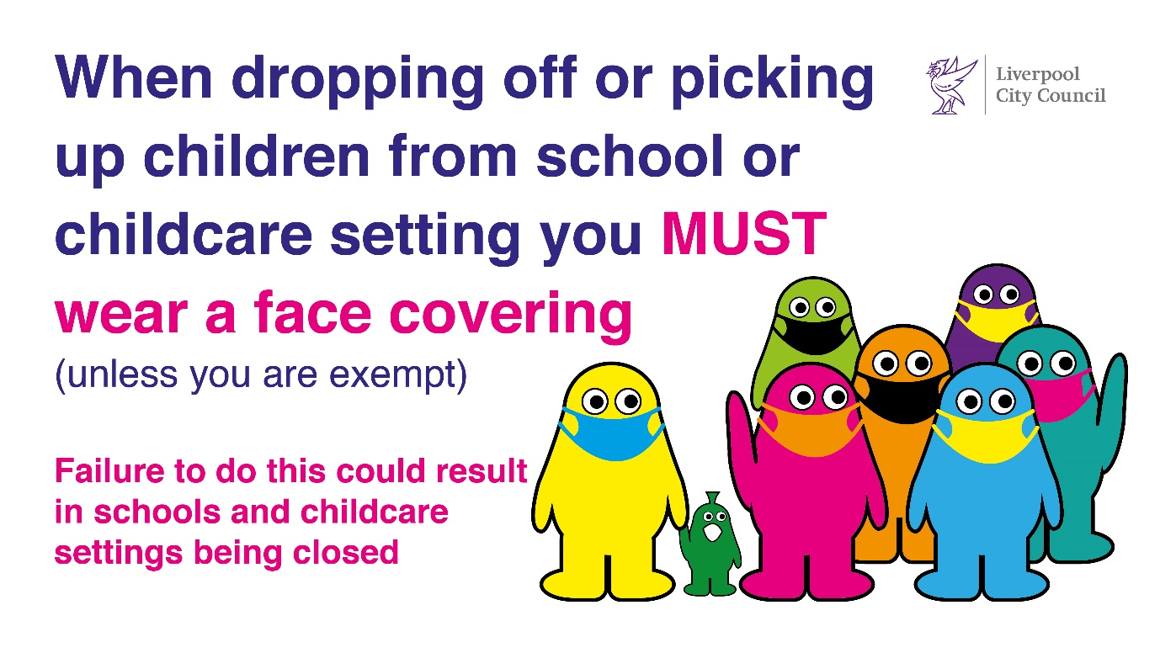
Our ref: JPC/MK
Be Covid Safe
Wear a face covering
Your ref:

22 October 2021

Dear Parent and Carers,

The following information is being sent out by all schools who are working together to combat the problem of violence against women and girls.

We are writing to you to ask for your support.

You will have seen much media coverage in recent months involving incidents of violence against women and girls. There have been distressing accounts and images of Sarah Everard, a marketing executive, who was handcuffed, kidnapped, raped and murdered walking home and also school teacher Sabina Nessa who was attacked, assaulted and murdered on her way for a drink with friends one evening recently.

Whilst this spotlight is helpful to highlight the issues women and girls face each day and to prompt discussion and action, it is also a depressing indictment of the society in which we live, that advances in human rights have not led to a reduction in violence against women and girls, nor a genuine and sincere appreciation of women and girls’ equal rights, their contribution to society and their right to co-exist with male counterparts as individuals of equal worth and value.

You may want to know what our schools are doing to tackle these issues.

Through PSHE, assemblies and class discussion time we educate our children about positive, healthy and respectful relationships, what respectful behaviour looks like, consent, gender roles, stereotyping, equality, body confidence and self-esteem, prejudiced behaviour and that violence and harassment are always wrong. With older children this will include violence and harassment that is sexual.

To highlight the size of the issue we have included, as an appendix to this letter, extracts from a recent OFSTED review of sexual abuse in schools and colleges. This is found at the end of our letter and we urge you to read it so that you can understand the size and impact of these issues from young people’s points of view, especially girls.

In addition to that extract, here is what OFSTED had to say about the limitations of schools’ actions:

‘Schools and colleges cannot tackle sexual harassment and sexual violence, including online, on their own, and neither should they. For example, the prevalence of children and young people seeing explicit material they do not want to see and being pressured to send ‘nudes’ is a much wider problem than schools can address. While they can play their part, it is not only their responsibility to solve it.’

So today we are asking for your support and to sit down with your own family members, where appropriate, and engage in discussion and dialogue about the following matters:

- Banter: the way 'banter' can lead to the trivialisation or normalisation of sexual abuse and violence against women - and the importance of challenging ‘banter’ for what it is; the sexualisation of females for the personal satisfaction of others
- Victim-blaming: the idea that someone ‘deserves it’ because of what they were wearing or where and when they were in a place. Nobody deserves to be degraded.
- Victim-shaming: using derogatory terms about someone, usually a girl, if they have engaged in sexual activity with a male or sending nude pictures, even though they may have been coerced, pressured, bullied, forced or tricked into it.
- Women as objects: giving marks out of ten, whistling at girls, making sexualised comments are all examples of how females are viewed as objects, not human beings.

As parents like you, all we have ever wanted is the best for our children, whether that be their quality of life, their education or in their own friendships and relationships.

Regardless of whether they are boys or girls, it is every child’s right to grow up experiencing:

- joy and peace in their lives,
- being hopeful for a future of their own making, based on their own interests,
- experiencing justice in all aspects of their lives and those around them,
- believing in the truth, justice and equality for all
- a deep faith in their ability to use their talents to be a force for good in this world.
We are working collaboratively with schools across Liverpool to make changes to the way women and girls are perceived in society and we hope you will join in and do the same. We also recognise there are many outstanding role models in our schools, male and female, but we need all people to treat women and girls with respect.

Please talk about it within your family network and how together we can bring about lasting changes in our society so that violence against women and girls is brought to an end, equality for all is achieved and justice prevails over those individuals who are intent on breaching others’ human rights.

Yours sincerely,


Mrs J P Conley
Headteacher
Appendix

The school inspection body OFSTED have published findings into a recent review of sexual abuse in schools and colleges. These were all mixed educational settings, however the findings are stark.

We would ask that you take a few minutes to read the following short extracts from the report and then take some time to digest the information and find some ways to help school to tackle these issues, whether they are happening online, outside or inside school.

Extract from OFSTED review:

The review has revealed how prevalent sexual harassment and online sexual abuse are for children and young people. It is concerning that for some children, incidents are so commonplace that they see no point in reporting them. It found that the issue is so widespread that it needs addressing for all children and young people. It recommends that schools, colleges and multi-agency partners act as though sexual harassment and online sexual abuse are happening, even when there are no specific reports.

On our visits, girls told us that sexual harassment and online sexual abuse, such as being sent unsolicited explicit sexual material and being pressured to send nude pictures (‘nudes’), are much more prevalent than adults realise. For example, nearly 90% of girls, and nearly 50% of boys, said being sent explicit pictures or videos of things they did not want to see happens a lot or sometimes to them or their peers.

Children and young people told us that sexual harassment occurs so frequently that it has become ‘commonplace’. For example, 92% of girls, and 74% of boys, said sexist name-calling happens a lot or sometimes to them or their peers. The frequency of these harmful sexual behaviours means that some children and young people consider them normal. When we asked children and young people where sexual violence occurred, they typically talked about unsupervised spaces outside of school, such as parties or parks without adults present, although some girls told us they also experienced unwanted touching in school corridors.

Children and young people, especially girls, told us that they do not want to talk about sexual abuse for several reasons, even where their school encourages them to. For example, the risk of being ostracised by peers or getting peers into trouble is not considered to be worth it for something perceived by children and young people to be commonplace. They worry about how adults will react, because they think they will not be believed, or that they will be blamed. They also think that once they talk to an adult, the process will be out of their control.

Children and young people were rarely positive about the RSHE (relationships, sex and health education) they had received. They felt that it was too little, too late and that the curriculum was not equipping them with the information and advice they needed to navigate the reality of their lives. Because of these gaps, they told us they turned to social media or their peers to educate each other, which understandably made some feel resentful. As one girl put it, ‘It shouldn’t be our responsibility to educate boys’.
Research in 2017 indicated that 26% of young people had sent a nude image to someone they were interested in and 48% had received one of someone else. However, more recent data on youth-produced sexual imagery for under-18s indicates that they are increasingly taking photos and videos of themselves to send to others. This includes incidents where they are groomed by adults to do so.

Data from the Internet Watch Foundation (IWF) shows a sharp increase in online sexual abuse images involving young people, which it partially attributes to a rise in the sharing of ‘self-generated’ content. In the first 6 months of 2020, 44% of all child sexual abuse content dealt with by the IWF was assessed as containing self-generated images or videos, compared with 29% in 2019.


