Headteacher: Mrs J P Conley
Deputy Headteacher: Mrs C Harkness

Teacher | Class
Miss L Haresnape | Year 6 | Key Stage 2 Lead
Mrs C Flynn | Year 5
Miss J Melia | Year 4
Miss C Osborne | Year 3
Miss J Connor | Year 2 | Key Stage 1 Lead
Mrs N Aslam | Year 1
Mrs K Makin | Reception | EYFS Lead
Miss K Regan | Nursery
Mrs C Whittaker | Currently on Maternity Leave



port Staff:

Admin:
Mrs M Kelly | Administrative Officer
Mrs P Dudley | Reception Desk Staff
Mrs J Monaghan | Reception Desk Staff

Classroom Support
Mrs S Barrett | Learning Support Assistant & Lunchtime support
Mrs S Edwards | Nursery Nurse & Lunchtime support
Mr J Fretwell | Learning Support Assistant & Lunchtime support
Mrs P McCormack | Learning Support Assistant & Lunchtime support
Ms D Rosario | Learning Support Assistant & Lunchtime support
Mr C Millington | HLTA / PE & sports & Lunchtime support
Mrs K Ryan | HLTA /Attendance Officer / PPA cover

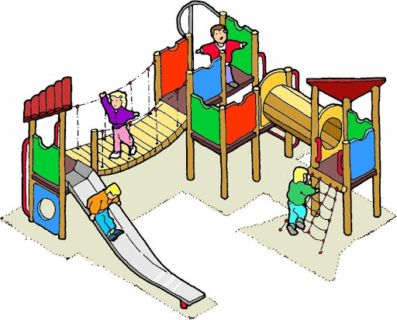
Lunchtime Support
Mrs P McCormack | Lunchtime Support Staff
Mrs P Spruin | Lunchtime Support Staff
Mrs Z Rahman | Lunchtime Support Staff

Premises Staff
Mr S Conning | Site Manager
Mrs S Jones | Cleaning Staff
Mrs Z Rahman | Cleaning Staff
Mrs M Rusk | Cleaning Staff
Mrs P Spruin | Cleaning Staff

Mrs J Wagner | Educational Welfare Officer

