

Class | Merit Award | Friendship Award | Special Award
1 | Oliver Donohue | Chloe Brennan | Grace Decourcy
2 | Poppy Edwards | Adam Suleman | Saffa Mohamoud
3 | Adelina-Maria Parus | Elena Iordan | Muhammed Kaya
4 | Messi Iordan | Natalya Fofana | Lewis Daniel
5 |  | Amelia Conroy  Amelia Miller | Georgie Byrne
6 | Miracle Kokey | Kenean Andeberhan | Khalil Bedja










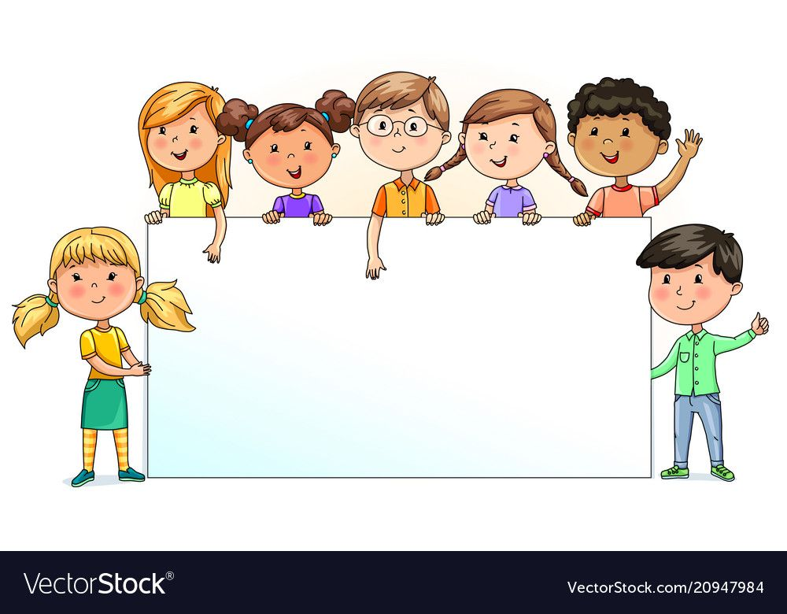

Nursery  % | Reception  % | Year 1  % | Year 2  % | Year 3  % | Year 4  % | Year 5  % | Year 6  %
94.12 | 90.48 | 95.71 | 97.00 | 94.09 | 93.10 | 93.24 | 95.29

