

Class | Merit Award | Friendship Award | Special Award
1 | Jaylen Tendo | Bobbie Rowlands | Tasneem Ali
2 | Junior Taylor | Andrea Bweya | Alby Hartley
3 | Darcie Carney-Feeley | Eskyas Tsegay | Lucas Gilbertson
4 | Lilly-Mae Lucas | Harvey Marsh | Megan McNulty
5 | Anna Hachem | Cali-Ruby Clarke | Nasra Ibrahim
6 | Dylan Gilbertson | Tina He | Kenean Andeberhan

+










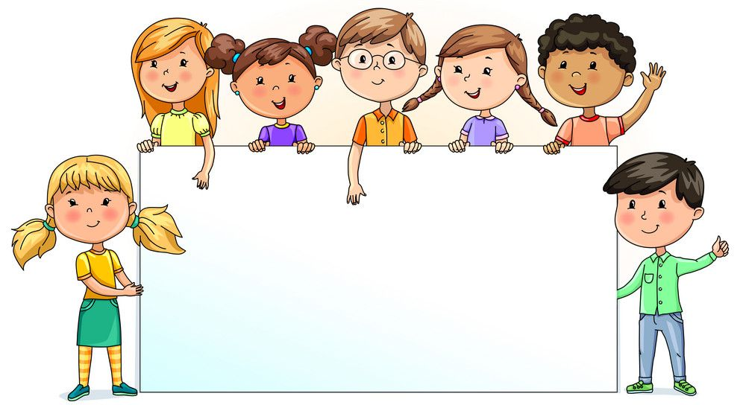

Nursery  % | Reception  % | Year 1  % | Year 2  % | Year 3  % | Year 4  % | Year 5  % | Year 6  %
79.46 | 90.83 | 99.05 | 86.00 | 98.18 | 91.20 | 95.95 | 87.06

