

Class | Merit Award | Friendship Award | Special Award
1 | Emir Radu | Rosie O’Callaghan | Elijah Lyons-Hughes
2 | Moise Iordan | Layla Caddick | Luke Moore
3 | Lucas Gilbertson | Alexandra Vasilescu | Yodit Gebremeskel Berhane
4 | Logan Bradley | Jacob Wincz | Khadija Enayet
5 | Mason Marsh | Cristian Vasilescu | Jessica Davies
6 | Giada Fernandez Bejarano | Joseph Makin | Gabriel Clements










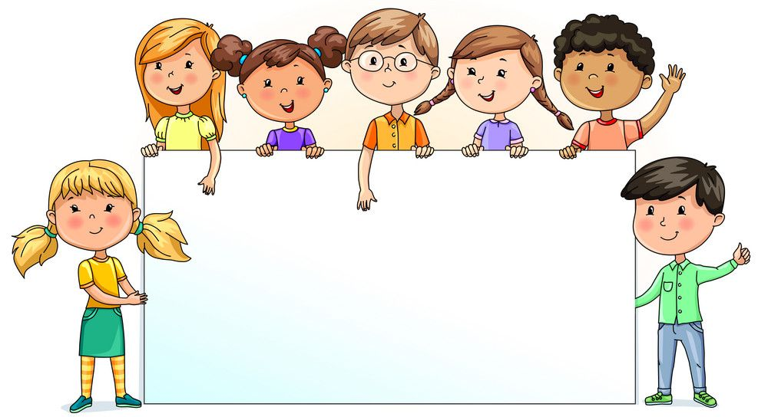

Nursery  % | Reception  % | Year 1  % | Year 2  % | Year 3  % | Year 4  % | Year 5  % | Year 6  %
81.31 | 88.57 | 96.19 | 93.50 | 100 | 98.62 | 92.67 | 95.88

