

Class | Merit Award | Friendship Award | Special Award
1 | Oliver Donohue | Dottie Lavelle | Lucas Brophy
2 | Adam Jaouai | Siana Jolla | Bryan Nosakhare Osawaru
3 | Adelina Parus | Alfie Clegg | Kaps Kabamba
4 | Lottie Creegan | Amelia Hughes | Jacob Brennan
5 | Mohamed Mahmoud | Aljouri Al Qarani | AJ Ogwuru
6 | Nawal Mohamoud | Joseph Makin | Miracle Kokey

+










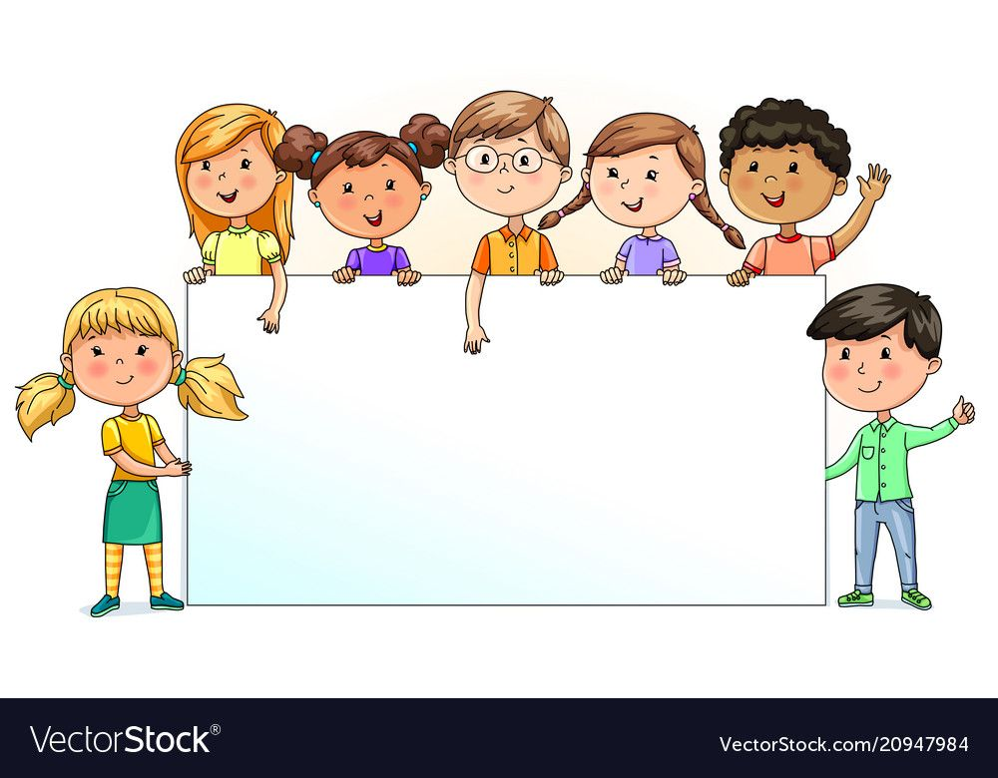

Nursery  % | Reception  % | Year 1  % | Year 2  % | Year 3  % | Year 4  % | Year 5  % | Year 6  %
92.31 | 87.83 | 92.38 | 95.26 | 96.36 | 92.14 | 94.67 | 88.82

