

Class | Merit Award | Friendship Award | Special Award
1 | Oghenefejiro Kubue | David Conroy | George Disley
2 | Moise Iordan | Sophia Costello | Leighton Brophy
3 | Eskyas Tsegay | Jack Duffy | Hope Duxbury
4 | Daniel Deakin | Tiffany He | Brielle Nosakhare Osawaru
5 | Amelia Miller | Ava-Rose Henry | Anna Hachem
6 |  | David Kabamba | Madison Cave

+










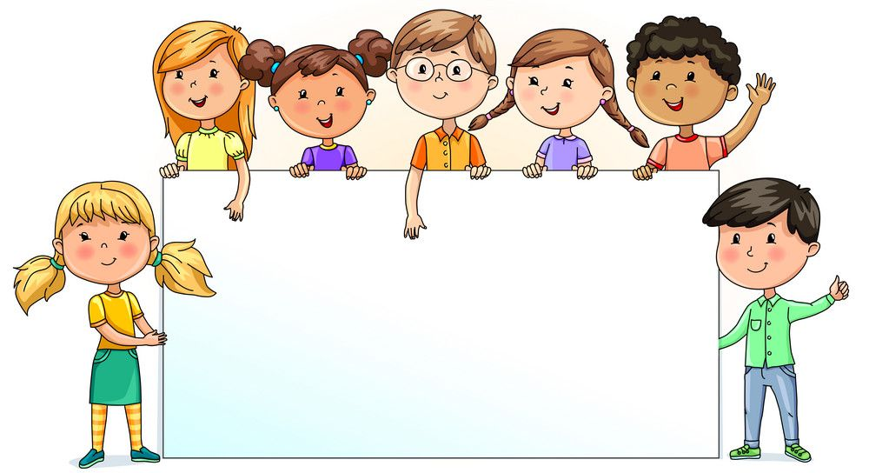

Nursery  % | Reception  % | Year 1  % | Year 2  % | Year 3  % | Year 4  % | Year 5  % | Year 6  %
90.00 | 83.18 | 94.29 | 96.84 | 98.18 | 96.43 | 98.00 | 92.94

