

Class | Merit Award | Friendship Award | Special Award
1 | Elijah Lyons-Hughes | Amir Radu | Chloe Brennan
2 | Junior Taylor | Saffa Mohamoud | Poppy Edwards
3 | Ayat Ali | Muhammed Kaya | Alexandra Vasilescu
4 | Lola Billingsley | Emily Rowlands | Rhia Wilcott
5 | Ali Mohamoud | Louie Byrne | Kian Creegan
6 | Benji Clarke | Maisie Johnson | Miracle Kokey

+










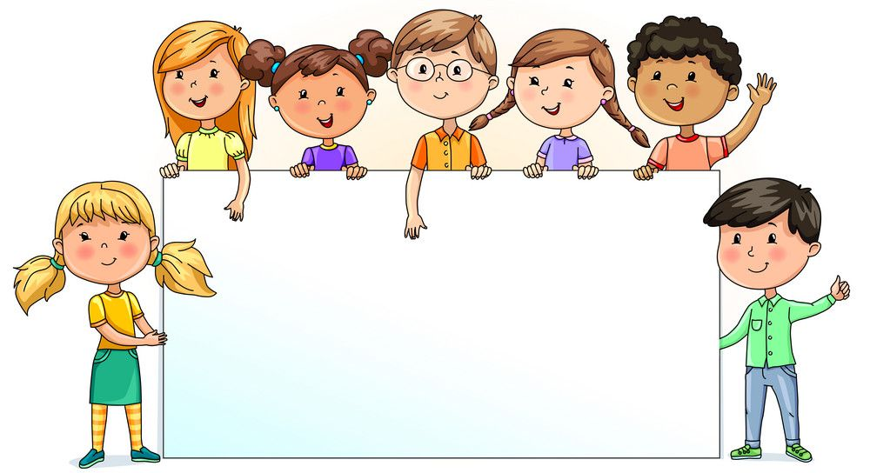

Nursery  % | Reception  % | Year 1  % | Year 2  % | Year 3  % | Year 4  % | Year 5  % | Year 6  %
88.46 | 94.55 | 99.05 | 98.95 | 99.09 | 97.14 | 99.00 | 98.75

